Environment：Linux

Instructions：

1. make

2. lsmod to check existing linux kernel

3. sudo insmod simple.ko

4. lsmod check whether the kernel has been loaded

5. dmesg to print content of the message in the kernel log buffer

6. sudo rmmod simple to remove kernel module

Load kernel

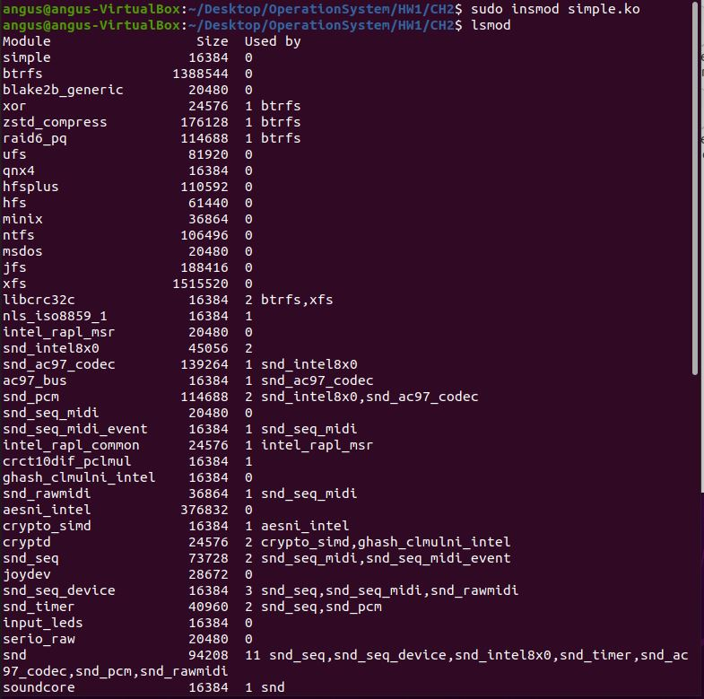

Remove kernel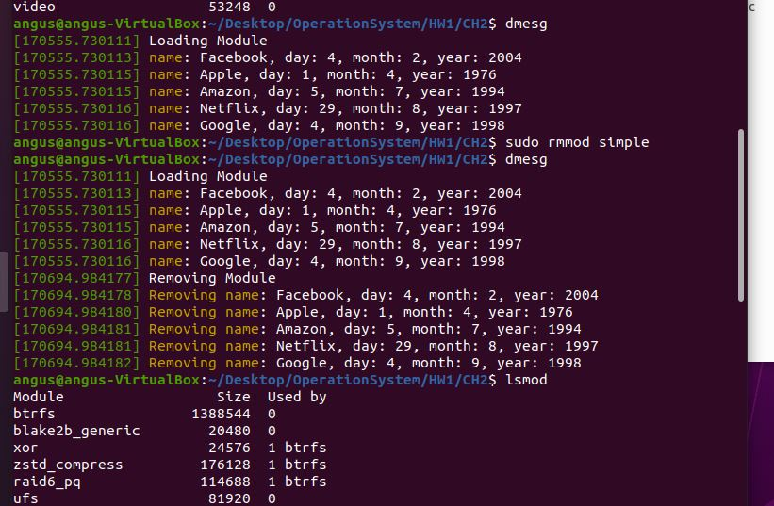

Source code：

#include <linux/init.h>

#include <linux/module.h>

#include <linux/kernel.h>

#include <linux/slab.h>

#include <linux/list.h>

static LIST_HEAD(birthday_list);

struct birthday

{

char *name;

int day;

int month;

int year;

struct list_head list;

};

void set_birthday(struct birthday *person, char *name, int day, int month, int year);

/* This function is called when the module is loaded. */

int simple_init(void)

{

struct birthday *Facebook, *Apple, *Amazon, *Netflix, *Google;

struct birthday *ptr;

printk(KERN_INFO "Loading Module\n");

Facebook = kmalloc(sizeof(*Facebook), GFP_KERNEL);

Apple = kmalloc(sizeof(*Apple), GFP_KERNEL);

Amazon = kmalloc(sizeof(*Amazon), GFP_KERNEL);

Netflix = kmalloc(sizeof(*Netflix), GFP_KERNEL);

Google = kmalloc(sizeof(*Google), GFP_KERNEL);

set_birthday(Facebook, "Facebook", 4, 2, 2004);

set_birthday(Apple, "Apple", 1, 4, 1976);

set_birthday(Amazon, "Amazon", 5, 7, 1994);

set_birthday(Netflix, "Netflix", 29, 8, 1997);

set_birthday(Google, "Google", 4, 9, 1998);

list_for_each_entry(ptr, &birthday_list, list)

{

printk(KERN_INFO "name: %s, day: %d, month: %d, year: %d \n", ptr->name, ptr->day, ptr->month, ptr->year);

}

return 0;

}

void set_birthday(struct birthday *person, char *name, int day, int month, int year)

{

person->name = name;

person->day = day;

person->month = month;

person->year = year;

INIT_LIST_HEAD(&person->list);

list_add_tail(&person->list, &birthday_list);

}

/* This function is called when the module is removed. */

void simple_exit(void)

{

struct birthday *ptr, *next;

printk(KERN_INFO "Removing Module\n");

list_for_each_entry_safe(ptr, next, &birthday_list, list)

{

printk(KERN_INFO "Removing name: %s, day: %d, month: %d, year: %d \n", ptr->name, ptr->day, ptr->month, ptr->year);

list_del(&ptr->list);

kfree(ptr);

}

}

/* Macros for registering module entry and exit points. */

module_init(simple_init);

module_exit(simple_exit);

MODULE_LICENSE("GPL");

MODULE_DESCRIPTION("Simple Module");

MODULE_AUTHOR("SGG");